**Online Course Platform: Student Performance & Engagement Analysis**

**Dataset Summary**

**Row Count**: 1,200  
**Columns**

* **Student_ID**
* **Name** (inconsistencies: all caps, lower case, trailing spaces)
* **Email** (some missing or malformed)
* **Gender** (Male, M, FEMALE, etc.)
* **Country** (India, india, IN, etc.)
* **Age** (some missing or invalid)
* **Enrollment_Date** (varied date formats)
* **Course_Name**
* **Course_Category** (e.g., Data Science, Business, etc.)
* **Progress** (%) (as strings, some with %, some without)
* **Time_Spent** (hrs) (some in minutes, some as text)
* **Completed** (Y, Yes, 1 / N, No, 0)
* **Feedback_Rating** (1 to 5, some blank, some out of range)
* **Session_Attendance** (comma-separated string of session dates)

**Part 1: Excel – Advanced Cleaning Tasks**

1. Convert 'Time_Spent' values into hours (handle "30 mins", "1.5", etc.).
2. Fix invalid/missing 'Age' entries using mean/median imputation.
3. Extract total sessions attended from the Session_Attendance column.
4. Filter out invalid email entries and identify duplicates.
5. Add a flag for "High Performer": Completed == Yes and Rating ≥ 4.
6. 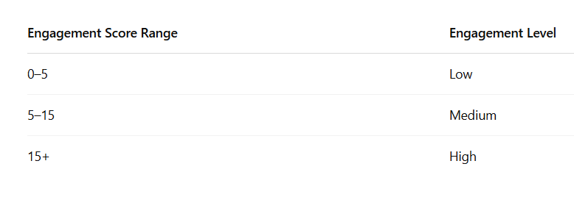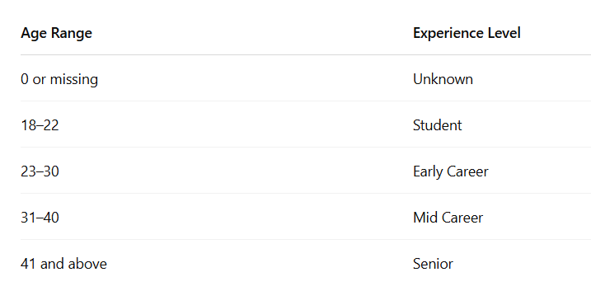Create new columns: Experience_Level (based on age: Student, Early Career, etc.) Engagement Level (based on Time Spent + Progress)

**Part 2: Power BI – Advanced Dashboard Tasks**

**Multi-page dashboard**:

* Overview Page (KPIs, summary)
* Category Analysis
* Engagement Heatmap

**KPI Cards**:

* Total Students, Avg. Progress, Avg. Rating
* Course Completion Rate

**Bar/Column Charts**:

* Students by Course Category
* Completion rate by Country

**Matrix Table**:

* Cross-tab: Course vs. Feedback Rating

**Line/Area Chart**:

* Enrollment trend by month

**Custom Measures** (DAX):

* Completion % by Category
* Avg. Time Spent per Category
* Correlation between Progress and Rating (scatter plot)

**Drill-through** to student details from summary cards.

**Use slicers**: Course Category, Country, Experience Level